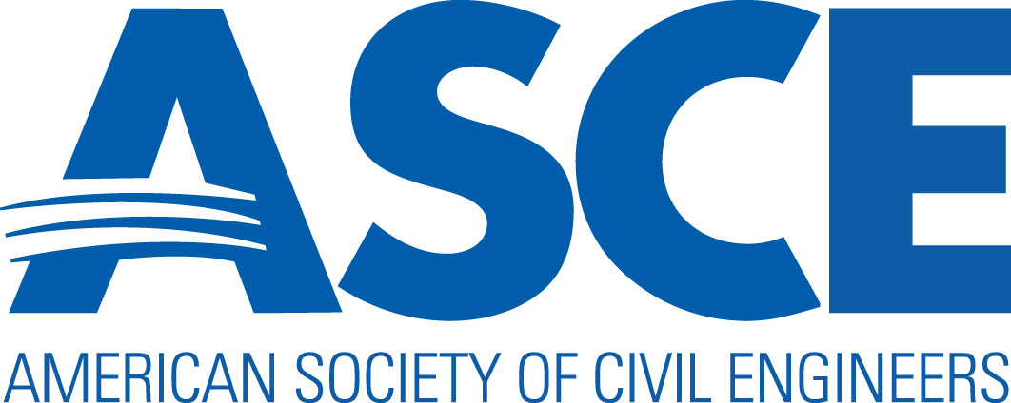

Outstanding Civil Engineering Achievement Award

ENTRY FORM

Part of the Outstanding Projects and Leaders Program

Projects reviewed by the New Hampshire Section for its annual best projects award may be determined worthy of consideration at the national level. Please use the following entry form for submission to ASCE-NH.

DEADLINE FOR ALL ENTRIES IS 5:00 PM EASTERN TIME, DECEMBER 15 TO ASCE-NH

Submit completed entries electronically to ASCE NH at newhampshire.asce@gmail.com

Revised February 10, 2016

Civil engineering achievement within New Hampshire is recognized annually by selection of the “NEW HAMPSHIRE OUTSTANDING CIVIL ENGINEERING ACHIEVEMENT”. The Award is presented for the achievement, not the individual, so that all who have worked on the winning project are recognized as having contributed to an outstanding civil works.

Entries are evaluated based on the following criteria:
Originality and Innovation
- New or Innovative Application of Technology, Design, Materials, Process/Methods, and Construction
Resourcefulness in Planning and Solving Design Challenges
- Complexity of the Problem or Situation Addressed
- Creativity in Solutions
Sustainability Considerations
- Environmental
- Social
- Economic
Project Planning and Delivery
- Financing, Budget, and Schedule
- Meeting the Client’s Needs
- Budget and Schedule Adherence
- Contributions to the Well-Being of People and Communities, including Aesthetic Value

Projects of the Year at the region, section, and branch level are expected to be entered for consideration at the national level.

Preparation Guidelines
Entries must address each criterion and should identify unusual aspects of the project. Describe key challenges and solutions and new technology used. Consider all phases of the project, including the plan, design, construction, operation, and maintenance. The project’s environmental, political, economic, social, and legal aspects may also be significant.

Present most technical information in lay terms. OCEA jury members have diverse backgrounds in civil engineering. The engineers and design professionals on the jury may have expertise in structures, for example, but not in environmental engineering. Entries will also be read by general media reporters who cover such civil engineering issues as transportation or the environment but who may not have engineering backgrounds.

Entry Format
All entries must be in English and should include the following in this order:
- Completed entry form
- Brief description of the project, not to exceed 250 words
- At least six color photographs of the project. (More images are encouraged. Include photo credits if necessary as ASCE may use photos for publicity purposes.)
- Summary describing how project meets judging criteria, not to exceed 1,000 words.
- Attachments such as articles from newspapers, magazines or journals, if available. If non-English articles are presented, their translation must be provided.

DEADLINE FOR ALL ENTRIES IS 5:00 PM EASTERN TIME, APRIL 15

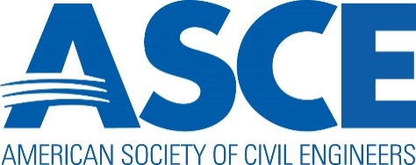 PROJECT NAME:

To determine whether or not your project is eligible for entry, please complete this page and then move on to the remaining pages as directed. Projects can be entered if they meet the following eligibility criteria. Identify your project by checking the appropriate box and attesting to its eligibility.

- Bridges, tunnels, waterways, railways, roads (other than toll): eligible only when carrying traffic; the time of final completion or dedication is not important.

- Toll or similar regional roads: any portion in use is eligible. The entire road is eligible when it is 75% operational.

- Water supply, flood control dams: eligible when ready to take the full design head of water.

- Power dams: eligible when the major civil engineering construction is completed and the structure can take its design head of water.

- Power plants: eligible when power is generated and delivered.

- Buildings and structures: eligible when ready for use (certificate of occupancy has been obtained where applicable).

- Airports and other similar large developments: eligible when initial phase is 75% operational. Individual structures or features (such as major buildings or runways) are eligible when operational, but will be considered separately from the entire project.

- Water supply, water treatment, and waste disposal: the entire project is eligible when it is 50% operational in its initial phase. Any completed component is eligible, but will be considered separately from the entire project.

- Port, coastal, ocean, wetlands projects, and offshore structures: eligible when complete.

- Military projects (such as bases, launching units, and harbor facilities): eligible when initial phase is 75% operational. Individual structures or features (such as major buildings or runways) are eligible when operational, but will be considered separately from the entire project.

I have placed my project in the category that best describes it and hereby attest, by the signing of my name, that is meets established eligibility requirements.

Signature: Date:

If your project meets eligibility requirements, continue the entry by completing remaining pages of this form.

PROJECT INFORMATION

Project name (exactly as it should appear on the trophy)
Presented by the
American Society of Civil Engineers to

Name of Owner:

Name of Project:

Outstanding Civil Engineering Achievement Award

Example: Potomac Crossing Consultants
Woodrow Wilson Bridge Project

Project Location (city/state):

ABOUT THE PROJECT

Scheduled Completion Date: Actual Completion Date:

Total Project Budget: Actual Cost:

NOMINATOR’S INFORMATION

Describe the Nominator’s Role:
- Nominator Only
- Active in the Project
If active in the project, describe activity:

Submitted by
Title
Company Name

Address

City, State, Zip

Country

Phone Email

Signature Date

PROJECT OWNER INFORMATION

Project Owner’s Name

Firm CEO

Firm Name

Firm Representative

Address

City, State, Zip

Country

Phone Email

TEAM LEADER INFORMATION

Contractual Team Leader’s Name

Company Name

Address

City, State, Zip

Country

Phone Email

Engineer of Record’s Name

Company Name

Address

City, State, Zip

Country

Phone Email

Architect of Record’s Name

Company Name

Address

City, State, Zip

Country

Phone Email

General Contractor’s Name

Company Name

Address

City, State, Zip

Country

Phone Email

CONTRACTOR/SUBCONTRACTOR INFORMATION

Please provide contact information for all contractors and subcontractors who contributed to this project. If more space is needed, please add lines.

Contact person’s name

Company Name

Address

City, State, Zip

Country

Phone Email

Contact person’s name

Company Name

Address

City, State, Zip

Country

Phone Email

Contact person’s name

Company Name

Address

City, State, Zip

Country

Phone Email

Contact person’s name

Company Name

Address

City, State, Zip

Country

Phone Email

Contact person’s name

Company Name

Address

City, State, Zip

Country

Phone Email

I hereby authorize submission of this project into the American Society of Civil Engineer’s Outstanding Civil Engineering Achievement (OCEA) Award competition.

Senior Executive/Principal

Company Name

Signature Date

Address

City, State, Zip

Country

Phone Email

APPLICATION CHECKLIST
Entry material for the Outstanding Civil Engineering Achievement (OCEA) Award should be presented in the following order:

All entries must be in English and should include the following in this order:
- Completed entry form
- Brief description of the project, not to exceed 250 words
- At least six color photographs of the project. (More images are encouraged. Include photo credits if necessary as ASCE may use photos for publicity purposes.)
- Summary describing how project meets judging criteria, not to exceed 1,000 words.
- Attachments such as articles from newspapers, magazines or journals, if available. If non-English articles are presented, their translation must be provided.

Submit completed entries electronically to ASCE NH at newhampshire.asce@gmail.com

DEADLINE FOR ALL ENTRIES IS 5:00 PM EASTERN TIME, APRIL 15.

